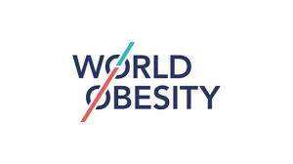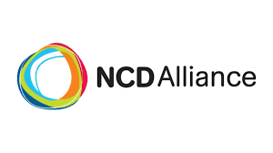

79th Session of the World Health Assembly
Individual statement

Agenda Item 15.4. Maternal, infant and young child nutrition

NCD Alliance, supported by World Obesity, welcomes Member States championing WHO’s Acceleration Plan to Stop Obesity and those adopting legislation aligned with the International Code of Marketing of Breast-milk Substitutes. We express concern that only 33 countries have substantial legal alignment, risking the achievement of breastfeeding targets. Moreover, with estimates showing 35.9% of young children consuming sweet beverages on the previous day, action is critical. We urge governments to integrate nutrition targets into national health strategies, enforcing fiscal policies like SSB taxes, restricting marketing of unhealthy foods, adopting mandatory front-of-package food labels, promoting breastfeeding, and safeguarding policy from conflicts of interest. Implementing these evidence-based measures is critical to reversing the childhood obesity epidemic and reducing future NCD risks globally.
Word count: 119/120

